**Manchester Industrial Relations Society 50th Anniversary Conference**

### The Changing Face of Employment Relations over the Last 50 Years

## Friday 21 November 2014

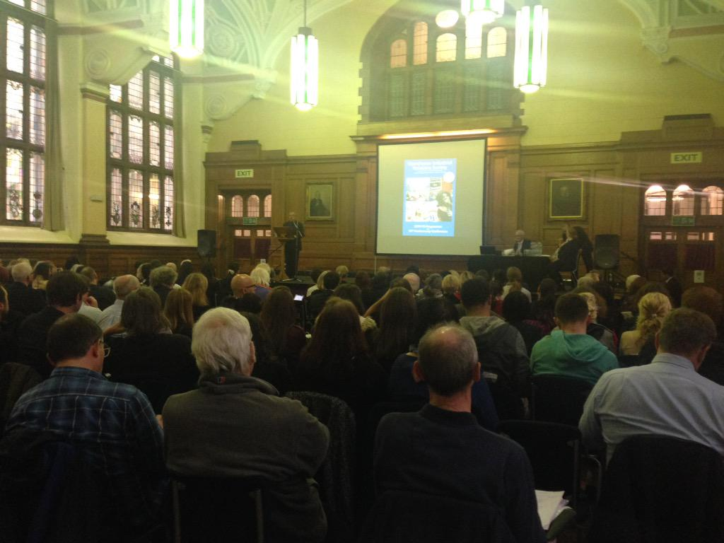

200 industrial relations academics from across the country, trade union officers from numerous unions (including the GMB, Unite, Ucatt, PCS and NUT) and the Trades Union Congress (TUC), Human Resource professionals from the Chartered Institute for Personal and Development (CIPD), officials from the Advisory, Conciliation and Arbitration Service (Acas), labour lawyers from the Industrial Law Society, and postgraduate employment relations/HRM students, packed out the Manchester Industrial Relations Society’s 50th anniversary conference which was held on 21 November at the University of Manchester.

The conference, organi***s***ed on the theme of *The Changing Face of Employment Relations over the Last 50 Years*, had anunrivalled line-upofspeakers offering a fascinating reflective historical commentary on the changes and continuities of the period, as well as considering future challenges and prospects. It provided an important testimony to the continuing theoretical and practical contemporary relevance of the field of employment relations***,*** and in the process celebrated the Manchester Industrial Relations Society’s distinctive contribution since 1964. The event was sponsored and financially supported by the CIPD, Acas, TUC, British Universities Industrial Relations Association, Salford Business School, Fairness at Work Research Centre at Manchester Business School, and Manchester Metropolitan University Business School. It was an intensive day chaired with military precision to ensure smooth time-keeping, with four separate sessions of two 20 minute back-to-back presentations, each of which was followed by questions and contributions from the floor before the speakers responded.

In the first session of the morning there were two presentations exploring respectively ‘The Changing Nature of Work and Employment’ (with Professor Jill Rubery from the Fairness at Work Group at Manchester University Business School) and ‘The Changing Nature of Collective Employment Relations’ (with Professor Paul Marginson (from the Industrial Relations Research Unit at the University of Warwick). Jill pivoted her presentation on the ‘Four Fs of Employment Change’: Who works: *Feminisation* - from mainly men to both men and women; How we work: *Flexibilisation* – from standard to flexible employment; For whom we work: *Fragmentation* – from single employer to multi-employers; and What work is for: *Financialisation* – from producing goods/services to financial value. Signalling the global and political forces shaping such changes over the last 50 years, she also commented on outcomes and future prospects in terms of both negative and positive features. Paul’s presentation examined the remarkable decline of collectivism as the main way of regulating employment, with reference to collective representation and organisation, collective bargaining coverage and structure, scope (agenda) of collective bargaining, and joint consultation arrangements. He highlighted three underlying processes: *‘marketisation’* (with a shift from an industrial/occupational frame to an enterprise frame in collective ER); *then rise of ‘micro-corporatism’* (with an increased focus on common interests of collective actors within an enterprise frame); *and the changing nature of voluntarism* (with attempts at a legally-induced or legislatively-prompted voluntarism leading to meagre outcomes, and ‘asymmetric’ voluntarism with management decisions increasingly predominant in determining ‘fact’ and trajectory of collective ER).

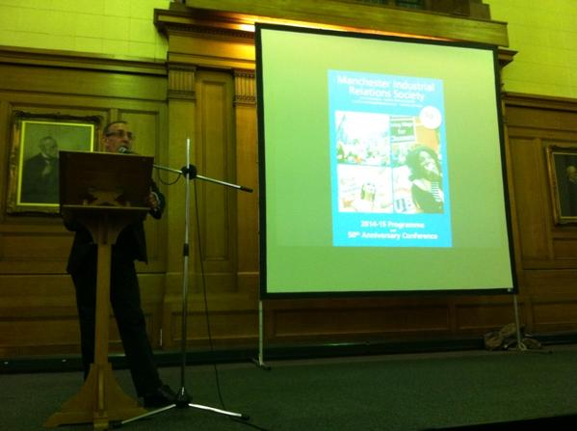

In the second morning session of the conference Mike Emmott (advisor to the CIPD) spoke on the topic of ‘From the Personnel Manager to HRM and Beyond’ and Sir Brendan Barber (Acas chair) spoke on ‘The Promotion of Good Employment Relations’. Mike’s presentation refocused analysis away from the field of ‘industrial relations’ to ‘employee relations’ (including issues related to managing the employment relationship/HR, conflict management, employee engagement, employee voice, ‘good practice’, and compliance with employment regulation). He probed whether employee voice is the new ER and the extent to which alternative dispute resolution could be integrated into strategic conflict management, and advocated the need to bring key ‘social partners’ together to form a hub for advising government on workplace issues and for a government-supported, sector-based and workplace-focussed campaign on productivity, performance and good work. Brendan’s presentation focused on three areas: *workplace disputes and how these have changed* (whilst collective action has declined, Acas still deals with around 800-900 collective conciliations each year and there has been a dramatic rise in individual disputes, whilst Acas places increased emphasis on alternative dispute resolution and good conflict management in the workplace); *the workplace itself and how this has changed* (growing fragmentation of the workplace largely driven by the increased use of outsourcing and often motivated by a drive for efficiency and cost cutting, thereby making good employment practices challenging, as is managing HR across organisational boundaries); *and the issue of legislation and its significance in the employment relationship* (with a growing interest in the use of what is often termed soft regulation – codes of practice or authoritative statements of good practice that have the approval of Parliament and have to be taken into account by the courts and tribunals in relevant situations, for example on discipline and grievance, time off for trade union duties and activities, disclosure of information for collective bargaining purposes, settlement agreements, right to request flexible working). Both speakers, as well as some people from the conference floor during Q&As, were involved in a lively debate about the controversial issue of employers’ blacklisting of trade unionists, including the alleged personal involvement of some leading CIPD members.

After lunch ‘The Past and Future of Trade Unionism’ was explored by Paul Nowak (Assistant General Secretary, TUC) and ‘Equality and Diversity in Employment Relations’ by Professor Sian Moore (Centre for Employment Studies Research, University of the West of England). Paul provided an overview of the key trends within the trade union movement over the past 50 years – and suggested an analysis of these trends might inform strategic decisions about the future of the movement. He set out three key phases in the development of the trade union movement between 1964 and 2014: the first phase, from 1964 to the late 1970s, which he characterised as a *period of growth and expansion*; the second phase, from the early 1980s to the mid ‘90s, which was effectively a *period of ‘survival’* with unions having to respond to the end of the post-war consensus, industrial change, the rise of de-regulation and Thatcherism; and a third phase, from the mid ‘90s to the present day – which he characterised as *‘resilience if not resurgence’*. Paul suggested unions could learn three key lessons from the half century after 1964: organising is crucial; unions can only grow if they reach out to new groups of workers; and unions need to be confident enough not to be within what Walter Citrine described as the ‘traditional walls of trade union policy’. In examining the changing face of employment relations with reference to equality and diversity, Sian’s’ presentation looked at the tension between voluntary and legal responses to discrimination as ‘vehicles for equality’ over the past 50 years, the shifting relationship between liberal and radical models of equality, self-organisation as the radical political response?, and intersectionality – a liberal or radical response? In the process she argued there had been a failure of the liberal model to deliver equality, the incorporation of feminism into the neoliberal programme, and the failure of voluntarism in the context of weakened unions, and advocated the need for radical self-organisation within and outside the workplace.

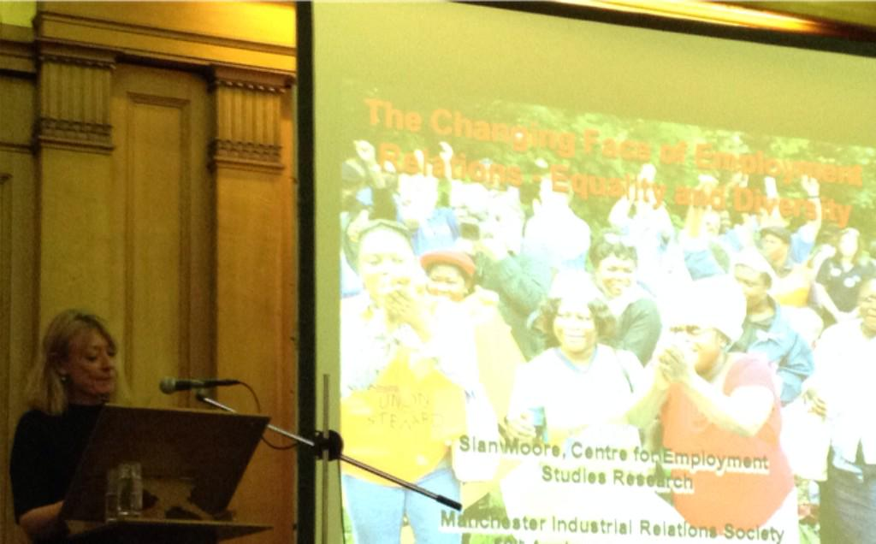

The final conference session had presentations on ‘State Regulation of Employment Relations’ from Professor Richard Hyman (London School of Economics) and ‘Conflict: Trends and Forms of Collective Action’ by Professor John Kelly (Birkbeck, University of London). Richard explored four main themes: (how) is the state an industrial relations ‘actor’; Britain: the eclipse of ‘collective laissez-faire’; the strange death of the ‘social market economy’; and the EU and the deconstruction of employment rights. In posing ‘what is to be done’ he flagged up the need for both material and ideational responses, *in* and *against* the state, and international solidarity. In the process he questioned whether deregulation really means removing rules, or just changing who rules are made by. Meanwhile John concentrated attention on strike activity and its changing patterns (notably the decline of union density, organisational capacity and bargaining coverage shrinking the opportunity structures through which to pressure employers), but argued declining conflict *at* work does not entail a decline in conflict *about* work. He then proceeded to consider varieties of collective action (coalition building between unions and civil society, political lobbying of key decision makers at different levels, online petitions and social media, occupations of public spaces, and general strikes and demonstrations) and considered the links between strike and protest waves in Europe and the restructuring of class representation in the political system. He argued that strikes are good for union membership and that successful unions reduce the rate of profit, which is a good thing because it is a form of wealth redistribution.

Later in the evening, at the after conference meal in Chinatown, Professor Roger Seifert (University of Wolverhampton) spoke on ‘The British Industrial Relations Tradition Over the Last 50 Years’. While presented in a jocular fashion, befitting the informal occasion, he provided a forthright and provocative critique of the highly negative role leading IR academics of the 1960s played in compromising a critical analysis of the antagonistic dynamic of the employment relationship, something which has been accentuated with the academic study of HRM in Business Schools.

Following on from the conference, most of the presentations are being written up for publication in a special (bumper) issue of the journal *Employee Relations* edited by Professor Ralph Darlington (Secretary of the Manchester Industrial Relations Society) in what is likely to be a seminal issue that can be an important teaching and research resource for many years to come. Discussions are currently taking place to explore the possibility of making it more generally accessible to practitioners in organisations like CIPD, Acas and the TUC, on the basis that it will be required reading for anybody who has either an academic or professional interest in industrial relations, work and employment. PowerPoint presentation slides will also be made available on the MIRS website: <http://www.mirs.org.uk/>

A BBC 20-minute news film which was displayed prior to the conference commencing and at lunchtime (showing a variety of old clips about employment and industrial relations issues) was produced by the North West Film Archive, based at Manchester Metropolitan University, and is available for viewing at the NWFA in Manchester Central Library, St. Peters Square (DVD no. 5962).

***Conference Sponsors***

Manchester CIPD; North West TUC; North West Acas; British Universities Industrial Relations Association; Salford Business School; Fairness at Work Research Centre at Manchester Business School; Manchester Metropolitan University Business School

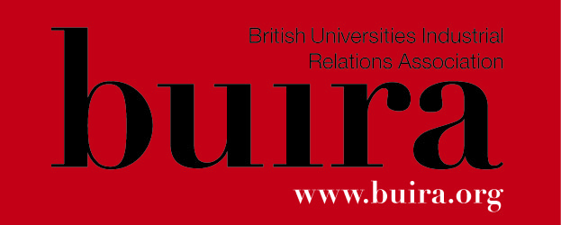

toplogo