MANCHESTER INDUSTRIAL RELATIONS SOCIETY
www.mirs.org.uk twitter: @ManchesterIRS
50th Anniversary Conference

The Changing Face of Employment Relations over the Last 50 Years

Friday 21 November 2014
The Great Hall, Sackville Street Building, University of Manchester http://www.conference.manchester.ac.uk/home/74-sackville-street-building

9.00am-10.00am

Registration and Refreshments

10.00-11.15am

The Changing Nature of Work and Employment

Professor Jill Rubery (Fairness at Work Research Group, Manchester Business School, University of Manchester)

The Changing Nature of Collective Employment Relations

Professor Paul Marginson (Industrial Relations Research Unit, University of Warwick)
Chair: Professor Ralph Darlington (Salford Business School University of Salford)

11.15-11.30am: Break

11.30am-12.45pm
From the Personnel Manager to HRM and Beyond
Mike Emmott (Employee Relations advisor, Chartered Institute for Personnel and Development)
The Promotion of Good Employment Relations
Sir Brendan Barber (chair of Advisory, Conciliation and Arbitration Service)
Chair: Professor Irena Grugulis (Centre for Employment Relations, Innovation and Change University of Leeds)

12.45-1.45pm: Buffet Lunch

1.45-3.00pm
The Past and Future of Trade Unionism
Paul Nowak (Assistant General Secretary, Trades Union Congress)
Equality, Diversity and Employment Relations
Professor Sian Moore (Centre for Employment Studies Research, University of the West of England)
Chair: Lyn Collins (North West Regional Secretary, Trades Union Congress)

3.00-3.15pm: Break

3.15-4.30pm

State Regulation of Employment Relations
Professor Richard Hyman (Employment Relations and Organisational Behaviour, London School of Economics)

Conflict: Trends and Forms of Collective Action
Professor John Kelly (Department of Management, Birkbeck, University of London)
Chair: Peter Monaghan (North West Area Director, Advisory, Conciliation and Arbitration Service)

Conference Sponsors
Manchester CIPD; North West TUC; North West Acas; British Universities Industrial Relations Association; Salford Business School; Fairness at Work Research Centre, Manchester Business School; Manchester Metropolitan University Business School


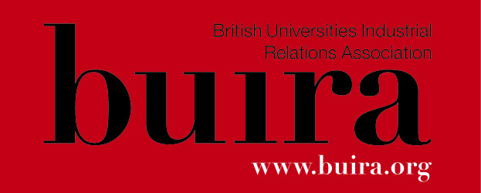





Manchester Industrial Relations Society (MIRS)
Conference Fee and Registration
MIRS member for 2014-15 (no fee); waged non-MIRS member (£10.00)
or student/unwaged non-MIRS member (£5.00)

Pre-booking is essential
The cost of the conference includes tea/coffee throughout the day and a buffet lunch
Reduced conference rate nearby accommodation available: The Days Hotel: Ref No: GA00291
http://www.dayshotelmanchester.co.uk/

I want to register for the Conference:
Please delete as appropriate: MIRS member for 2014-15 (no fee); waged non-MIRS member (£10.00); student/unwaged non-MIRS member (£5.00)

Name (please print clearly)

Email (please print clearly) _________________________________________________

Address (please print clearly)

Organisation

Position held

Cheques should be made payable to “Manchester Industrial Relations Society”
Send your conference booking form and cheque to: Professor Ralph Darlington, Salford Business School, University of Salford, Salford M5 4WT; email: r.r.darlington@salford.ac.uk; phone: 0161-295-5456

……………………………………………………………………………………………………...

Membership of the Manchester Industrial Relations Society 2014-15
£25 waged; £5 students/unwaged

I want to become a member of the Manchester Industrial Relations Society 2014-15
Please delete as appropriate: £25.00 (waged) or £5.00 (students/unwaged)
Cheques should be made payable to “Manchester Industrial Relations Society” and forwarded to the Secretary at the address above
Name (please print clearly)

Email (please print clearly) _________________________________________________

Address (please print clearly) _

Organisation

Position held

